The literature landscape on 1.5°C Climate Change and Cities – Supplementary Material

*William F. Lamb1, Max W. Callaghan1, Felix Creutzig1,2, Radhika Khosla3, Jan C. Minx1,4*

*Affiliations*

*1 Mercator Research Institute on Global Commons and Climate Change, Berlin*

*2 Technical University Berlin*

*3 Centre for Policy Research, New Delhi*

*4 Hertie School of Government, Berlin*

## Literature search

Our data originates in a Web-of Science literature query (all document types) for an unrestricted time period (the final search was performed on Oct. 12, 2017, 11:52 a.m.). Web of Science (WOS) is a subscription-based scientific citation indexing service that provides a comprehensive citation search.

Several discrete steps were taken to develop the literature search. (1) We first identified four overarching urban topics judged to directly or indirectly contribute to urban climate change mitigation, as widely discussed in the literature: transportation, buildings, waste management, urban form and city-level mitigation plans and policies. (2) Based on the authors’ expertise, we specified a list of keywords, grouped by each topic area. (3) We used the keywords on the WOS platform, identifying more relevant terms, and removing terms that delivered spurious results. (4) We downloaded the titles and abstracts, for each topic assigning random samples of 25 documents to the authors. (5) We developed a simple criteria to rate documents as either ‘relevant’ or ‘not relevant’: “is this document relevant for an assessment of urban demand-side climate mitigation, in the fields of transportation, buildings, waste management, or urban form?” (6) Two authors then reviewed their random samples, which were cross-checked for consistency. (7) We repeated steps 3-6 until approximately 90% of the documents in each topic were deemed relevant. For transparency, the full search query is provided below.

During this process, we applied certain restrictions to the query. The first restriction is to narrow our search to an urban context. In particular, this is necessary for transportation and waste management, as in other areas the urban context is largely implicit (e.g. urban form, urban climate action plans). In the case of buildings, we omit this restriction, assuming that the bulk of building mitigation options apply to cities. The result of this restriction and selection of topics is to narrow the urban literature towards demand-side energy and material use, while excluding the supply-side impacts of energy and material production. Although supply-side activities also take place within cities, they are well captured by other research communities (e.g. IAMs); by contrast, the demand-side of climate change mitigation has received less attention in the literature and is a natural point of focus for an assessment of urban systems, as the everyday practices and uses of energy in transport, buildings, and infrastructures are all highly influenced by urban form, development, and city-level planning and policies.

The second restriction, applied to all topics in the query, is to focus only on policies or policy-relevant research. In practice this restriction is achieved with a relatively broad string of hard policies (subsidies, grants, taxes, etc.) and soft policies (information, education, certification, etc.), with the result that more descriptive research tends to be excluded. Given the enormous body of existing climate change literature, the short timeframe for assessing the 1.5°C goal, and the increasing need to focus assessments on policies, this seems to be a reasonable restriction. Importantly, it will include city-level policies that are not directly oriented towards mitigation, but are relevant for, for example, public transportation provisioning.

Our search results in a fairly restrictive selection of papers that is by no means comprehensive, but is sufficient to provide an overview of the major topics of urban climate change mitigation. Obviously, diverging emphasis and wording in the search query could be equally plausible. For example, a broader focus on infrastructure provisioning may be relevant (e.g. electricity access, affordable housing), but this is perhaps better suited to a sustainability themed assessment of the urban literature, rather than our narrower climate change mitigation focus.

In the following tables, each row represents a search query entered into Web of Science using the “advanced search” function.

## Transport

|  |  |  |
| --- | --- | --- |
|  | **AND…** | |
| **Sub-topics** | **Urban context** | **Policies** |
| **Public transport (specific)**  TS = ("bus" OR "metro" OR "subway" OR "train" OR "light rail" OR "heavy rail" OR "tram" OR "railway") AND ("transport*" OR "traffic" OR "commut*" OR "travel*") | AND TS = ("urban*" OR "municipal" OR "city" OR "cities" OR "metropolitan") | AND TS = (("provision*" OR "subsid*" OR "incentive*" OR "grant*" OR "regulat*" OR "governance" OR "codes" OR "standards" OR "tax*" OR "compliance" OR "zoning" OR "pricing" OR "planning" OR (("public" OR "state" OR "government" OR "infrastructure") NEAR/3 ("investment*" OR "procurement" OR "financ*")) OR ("information campaign" OR "marketing" OR "participatory" OR "public awareness" OR "education" OR "cooperation" OR "labels" OR "certifi*"))) |
| **Public transport (generic)**  TS = ("public" NEAR/3 ("transit" OR "transport*") OR ("mass" OR "rapid") NEAR/3 "transit") |
| **Intermodal travel**  TS = ("modal shift" OR "park and ride" OR "car sharing" OR "bicycle sharing" OR “active travel” OR ("intermodal" AND ("travel" OR "transport") |
| **Electric Vehicles**  TS = ("electric" NEAR/1 ("car" OR "vehicle" OR "taxi")) |
| **Transport mitigation (generic)**  TS = ("transport*" AND ((("climat* chang*" OR "global warm*" OR "carbon emission*" OR "greenhouse gas" OR GHG OR CO2) NEAR/3 mitigation) OR decarboni*ation OR "energy demand reduction*" OR "energy efficienc*" OR ("low carbon" AND "climat* chang*"))) |
| **Active travel**  TS = ("bicycle" OR "pedestrian*" OR "walking" OR "cycling" OR "rickshaw*") NEAR/2 ("infrastructure*" OR "path" OR "paths" OR "trail*" OR "network" OR "route*" OR "corridor*" OR "lane*") | |
| **Congestion and parking**  TS = (("congestion" OR "parking") NEAR/3 ("charg*" OR "tax" OR "pric*" OR "policy") AND ("transport*" OR "traffic" OR "vehicle" OR "car" OR "travel" OR "urban")) OR TS = "parking management" | | |

**Note:** Filters were applied to generic public transport (NOT TS = “cell”) and active travel (NOT TS = “evacuation”) due to unexpected results not within our search criteria.

## Buildings

|  |  |  |
| --- | --- | --- |
|  | **AND…** | |
| **Topics** | **Energy and building context** | **Policies** |
| **Thermal comfort**  TS = (“heating” OR “cooling” OR “thermal comfort” OR “air condition*” OR “thermostat” OR “HVAC” OR “boiler” OR “insulation” OR “ventilation”) | AND TS = ((“energy” OR “carbon” OR “CO2” OR “GHG” OR “greenhouse gas”) NEAR/3 (“saving*” OR “conservation” OR “perform*” OR “efficiency” OR “reduc*” OR “use” OR “mitigation” OR “green”)) AND ("buildings" OR “occupant*” OR “household*” OR “office*” OR “dwelling*” OR “housing” OR “building stock” OR “built environment”) | AND TS = (("subsid*" OR "incentive*" OR "grant*" OR "regulat*" OR "governance" OR "codes" OR "standards" OR “LEED” OR "tax*" OR "compliance" OR (("public" OR "state" OR "government" OR "infrastructure") NEAR/3 ("investment*" OR "procurement" OR "financ*")) OR (“information campaign” OR “marketing” OR “participatory” OR “public awareness” OR “education” OR “cooperation” OR “labels” OR "certifi*"))) |
| **Appliances & energy services**  TS = (“lighting” OR “appliance*” OR “refrigerat*” OR “cooking” OR "electrical device*" OR “energy service*” OR “electricity”) |
| **Consumption behaviour**  TS = (“consumption” OR “behavior*” OR “lifestyle” OR “sufficiency” OR “rebound” OR “satisfaction”) |
| **Green buildings**  TS = ("cool roofs" OR "green roofs" OR "passive house" OR "net zero" OR "mixed mode" OR "zero energy" OR “green building*” OR albedo OR “green design” OR “sustainable design”) |

**Note**: A filter was applied to thermal comfort (NOT TS = “thermal regulation”), as this resulted in an overly-technical literature that was not within our search criteria.

## Waste management

|  |  |  |
| --- | --- | --- |
|  | **AND…** | |
| **Topics** | **Urban context** | **Policies** |
| **Waste management**  TS = ("biological treatment" OR ("waste" OR "landfill") NEAR/3 ("management" OR "prevention")) | AND TS = ("urban*" OR "municipal" OR "city" OR "cities" OR "metropolitan") | AND TS = (("subsid*" OR "incentive*" OR "grant*" OR "regulat*" OR "governance" OR "codes" OR "standards" OR "tax*" OR "compliance" OR "zoning" OR (("public" OR "state" OR "government" OR "infrastructure") NEAR/3 ("investment*" OR "procurement" OR "financ*")) OR (“information campaign” OR “marketing” OR “participatory” OR “public awareness” OR “education” OR “cooperation” OR “labels” OR "certifi*"))) |
| **Recycling and composting**  TS = (("household*" OR "residential" OR "business*" OR "municipal" OR "council" OR "metropolitan") NEAR/3 (“recycling” OR “composting”)) | |

**Note**: A filter was applied to recycling and composting (NOT TS = “revenue recycling”) due to unexpected results not within our search criteria.

## Urban form, infrastructure, and city-wide mitigation policy

|  |  |  |
| --- | --- | --- |
|  | **AND…** | |
| **Topics** | **Urban context** | **Policies** |
| **Lock-in**  TS = ("lock-in" OR "path dependen*" OR "development path") AND ("infrastructur*") | AND TS = ("urban*" OR "building*" OR "municipal" OR "city" OR "cities") | AND TS = ("subsid*" OR "incentive*" OR "grant*" OR "regulat*" OR "governance" OR "codes" OR "standards" OR "tax*" OR "compliance" (("public" OR "state" OR "government" OR "infrastructure") NEAR/3 ("investment*" OR "procurement" OR "financ*")) OR (“information campaign” OR “marketing” OR “participatory” OR “public awareness” OR “education” OR “cooperation” OR “labels” OR "certifi*")) |
| **Urban form**  TS = (“urban form” OR “compact city” OR "dense city" OR (“low-carbon” AND “urban” AND “transition”) OR “transit-oriented development” OR “integrated land use and transport planning” OR “green infrastructure”) | |
| **Urban mitigation (generic)**  TS = (("CO2" OR "carbon" OR "GHG" OR "greenhouse gas" OR "climate change") NEAR/1 ("trading" OR "tax" OR "control" OR "regulation" OR "mitigation" OR "decarbonisation") AND ("urban" OR "municipal" OR "city" OR "cities" OR "metropolitan") NOT ("adaptation" OR "resilience" OR "flood*" OR "rural")) OR TI = (("urban" OR "municipal" OR "city" OR "cities" OR "metropolitan") AND ("decarbonisation" OR "energy efficiency" OR "low-carbon" OR (("CO2" OR "carbon" OR "GHG" OR "greenhouse gas" OR "climate change") AND ("trading" OR "tax" OR "control" OR "regulation" OR "mitigation" OR "reduction")))) | | |
| **Urban climate governance**  (TI = ((("climate change" AND ("poli*" OR "plan" OR "governance")) OR "climate poli*" OR "climate governance" OR "climate protection" OR "energy poli*") AND ("urban*" OR "municipal" OR "city" OR "cities" OR "metropolitan" OR "local")) NOT TS = ("adaptation" OR "resilience" OR "flood*")) | | |

Note: A filter was applied to generic urban mitigation and urban climate governance (NOT TS = ("adaptation" OR "resilience" OR "flood*")) to exclude adaptation focused climate policy.

## General exclusions

A further general set of exclusions was applied to the entire search query to remove unexpected results: NOT TS = ("TRAM-34" OR "taxa" OR "subsidence" OR "ataxia").

## Methods

## Automated content analysis

We apply Non-Negative Matrix Factorisation to identify latent topics in the document set, representing the various themes that characterize the urban mitigation literature [1]. As a first step, we prepare the data, removing common stopwords (the, and, etc.) and stemming each word (replacing both “congested” and “congestion” with “congest”). Then we construct a matrix of terms by documents. The cells of the matrix are filled with the term frequency inverse document frequency weighting (tf-idf) [2]. Briefly summarized, term Frequency ${tf}_{t,d}$ refers to the frequency with which a term $t$ occurs in document $d$. Inverse document frequency refers to the number of documents a term $t$ occurs in, or document frequency ${df}_{t}$, relative to the total number of documents in a collection $N$: ${idf}_{t}=log\frac{N}{{df}_{t}}$. The term frequency inverse document frequency weight for term $t$ in document $d$ is then ${tfidf}_{t,d}={tf}_{t,d}×{idf}_{t}$. Tf-idf scores thus assign higher weights to terms in a document, if the term appears infrequently across all documents, and vice versa.

This matrix $V$ is factorized into two matrices $WH$, whose product approximates $V$. $W$ describes a set of topics, where rows are topics, columns are words, and each cell is a word-topic score. $H$ describes the documents, where each row is a document, each column is a topic, and each cell a document-topic score. Topics can be understood as lists of high-scoring words, and documents are combinations of those topics. The analysis was implemented using scikit-learn [3].

As the number of topics needs to be specified exogenously, we sample different numbers of topics and analyze the resulting word distributions manually. Overall, 27 topics proved to be a meaningful and manageable number, covering a broad spectrum of themes, while minimizing uninterpretable results.

The method is applied to abstracts only, As we do not have the comprehensive library coverage to obtain all the documents, andWoS do not make full-texts available for text-mining.. Performing the analysis on full texts would likely increase the number of topics (due to the greater quantity and variety of words), potentially revealing more detail on the existing broad set of topics, or new information on topics systematically absent from abstracts (e.g. methods and data). However, this may come at the expense of a manageable and interpretable number of topics.

## Scientometric analysis

We implemented the scientometric analysis using VOSviewer, a program for mapping and clustering bibliometric data [4]. We used a bibliographic coupling network, specifying links (edges) between documents (nodes) based on their propensity to cite similar literature. Due to computational constraints, we limit the visualization to 1,500 nodes, each with a minimum of 5 coupled citations. VOSviewer implements a well-known modularity function to detect clusters in the network [5].

## Additional figures

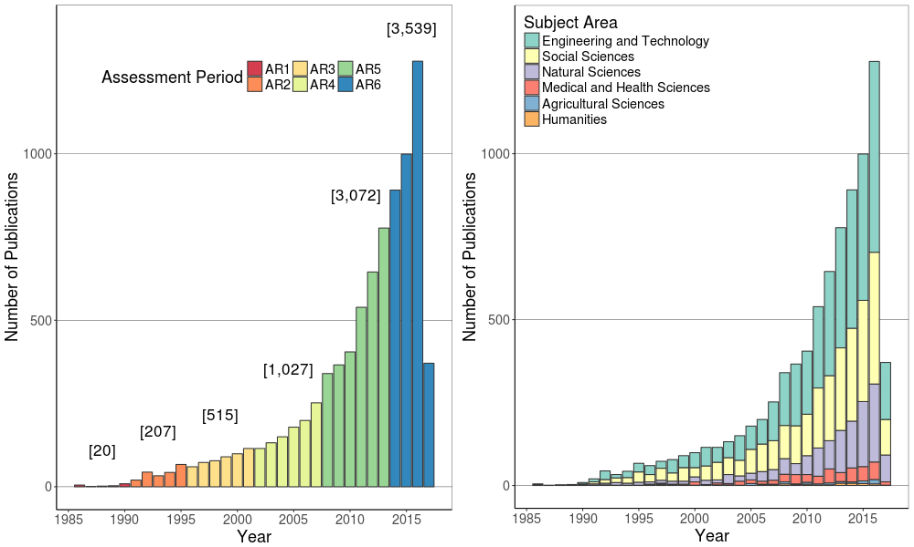

**Figure 1: Urban climate change mitigation publications by year and discipline**

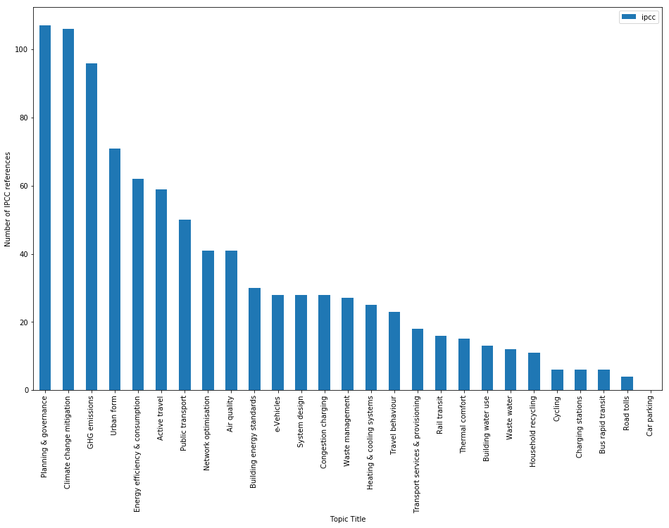

**Figure 2: IPCC references of the urban mitigation literature, counted by topic.** There are 129 papers in total. References were scraped from IPCC assessment reports, and matched with our database. Matches were counted in a topic bar if the topic score for that document was above 0.015. See section 2.1 for a description of the topic analysis.

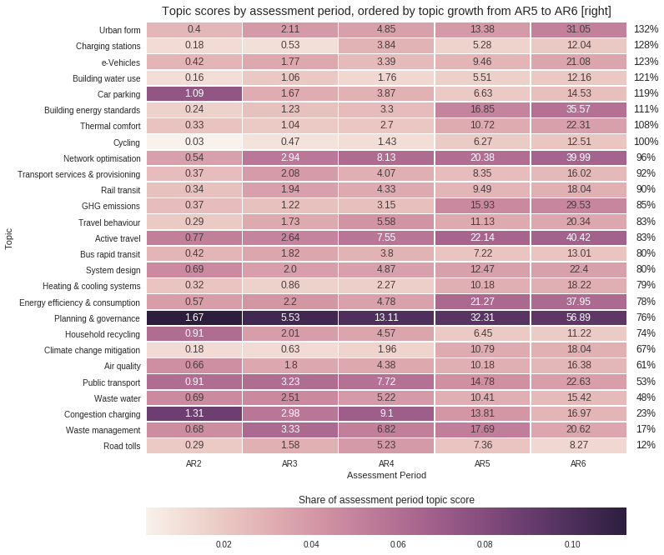

**Figure 3: Topic scores by IPCC assessment period.** Each cell shows the sum of each topic’s scores in each assessment period. Cells are coloured by the score as a proportion of the sum of all topic scores for documents written during each assessment period. Topics are shown in descending order by percentage growth from AR5 to AR6. These values are given on the right-hand side. The assessment periods correspond to 1991-1995 (AR2), 1996-2001 (AR3), 2002-2007 (AR4), 2008-2013 (AR5), 2014- (AR6). See section 2.1 for a description of the topic analysis.

## References

1. Lee DD, Seung HS: **Learning the parts of objects by non-negative matrix factorization. [Internet]**. *Nature* 1999, **401**:788–91.

2. Salton G, Buckley C: **Term-weighting approaches in automatic text retrieval**. *Inf. Process. Manag.* 1988, **24**:513–523.

3. Pedregosa F, Gramfort A, Michel V, Thirion B, Grisel O, Blondel M, Prettenhofer P, Dubourg V, Pedregosa F, Gramfort A, et al.: **Scikit-learn: Machine Learning in Python**. *J. Mach. Learn. Res.* 2011, **12**:2825–2830.

4. van Eck NJ, Waltman L: **Software survey: VOSviewer, a computer program for bibliometric mapping**. *Scientometrics* 2010, **84**:523–538.

5. Waltman L, van Eck NJ, Noyons ECM: **A unified approach to mapping and clustering of bibliometric networks**. *J. Informetr.* 2010, **4**:629–635.